**Data Science Related Questions**

**1.what is data science?**

Data science is the practice of collecting, cleaning, analyzing, and interpreting data to gain useful insights and make better decisions. It involves using tools and techniques to understand patterns and trends in the data.

**2.what is the use of data science in today world?**

Data science is used in many areas of today's world to improve processes, make informed decisions, and create new opportunities. Here are some key uses:

1. **Business**: Helps companies understand customer behavior, optimize marketing campaigns, and improve product development.
2. **Healthcare**: Aids in diagnosing diseases, personalizing treatment plans, and predicting outbreaks.
3. **Finance**: Detects fraud, manages risk, and informs investment strategies.
4. **Retail**: Personalizes shopping experiences, manages inventory, and optimizes pricing.
5. **Social Media**: Analyzes user interactions, improves content recommendations, and monitors trends.
6. **Transportation**: Optimizes routes, reduces fuel consumption, and improves safety.
7. **Education**: Enhances learning experiences, predicts student performance, and tailors educational content.
8. **Sports**: Improves player performance, informs game strategies, and enhances fan engagement.
9. **Environmental Science**: Monitors climate change, manages natural resources, and predicts natural disasters.

**3.Why do you think data science has come into existence?**

**Once upon a time**, in the early days of technology, businesses and researchers relied on simple tools like paper, calculators, and basic spreadsheets to manage and analyze data. Back then, the amount of data generated was relatively small and could be handled manually.

**As time passed**, technological advancements led to the creation of computers, which could process data much faster than humans. This allowed organizations to handle larger datasets, but the tools were still quite primitive. The focus was primarily on storing data and performing simple calculations.

**Then came the digital age**. With the invention of the internet, smartphones, and social media, the amount of data being generated exploded. Every click, like, purchase, and post created valuable information. Companies started to realize that within this massive sea of data, there were hidden treasures—insights that could transform their businesses.

**However, there was a problem**. The traditional methods of handling data were no longer sufficient. The data was too vast and complex. This is where the story takes an interesting turn.

**Enter the heroes of our story: the statisticians, computer scientists, and domain experts**. They joined forces, combining their knowledge of statistics, programming, and specific industries to create new ways of handling and analyzing data. They developed sophisticated algorithms, powerful computing tools, and advanced statistical methods. They could now uncover patterns, make predictions, and draw meaningful conclusions from massive datasets.

**This new approach needed a name**, and thus, data science was born. It was a blend of multiple disciplines, all working together to extract valuable insights from data.

**As the years went by**, data science proved its worth in various fields. In healthcare, it helped doctors predict diseases and personalize treatments. In finance, it detected fraudulent activities and informed investment decisions. In marketing, it helped businesses understand their customers better and tailor their offerings.

**The world began to change**. Companies that embraced data science thrived, making smarter decisions and staying ahead of their competitors. Everyday life improved as data science applications made transportation more efficient, online recommendations more accurate, and even entertainment more enjoyable.

**And so**, data science became an essential part of the modern world.

**4.Different types of Data analytics with example?**

Data analytics can be categorized into four main types: descriptive, diagnostic, predictive, and prescriptive analytics. Each type serves a different purpose and helps organizations understand their data in various ways. Here's an explanation of each type along with an example:

**1. Descriptive Analytics**

**Purpose**: Descriptive analytics aims to describe what has happened in the past. It involves summarizing historical data to understand changes over time and identify patterns.

**Example**: A retail company uses descriptive analytics to analyze its sales data from the past year. They create reports and dashboards showing total sales, sales by region, and monthly trends. This helps them understand how their business performed over different periods and in different locations.

**2. Diagnostic Analytics**

**Purpose**: Diagnostic analytics seeks to understand why something happened. It goes a step further than descriptive analytics by drilling down into the data to uncover the reasons behind past outcomes.

**Example**: Continuing with the retail company, suppose they noticed a significant drop in sales in one region during the last quarter. Using diagnostic analytics, they investigate various factors such as changes in marketing campaigns, competitor activity, and customer feedback. They discover that a new competitor opened several stores in that region, attracting their customers.

**3. Predictive Analytics**

**Purpose**: Predictive analytics aims to forecast what is likely to happen in the future. It uses historical data, statistical models, and machine learning techniques to predict future outcomes and trends.

**Example**: The retail company wants to forecast next quarter's sales. They use predictive analytics by analyzing past sales data, seasonal trends, and economic indicators. The predictive model suggests that sales are likely to increase by 10% due to an upcoming holiday season and a positive economic outlook.

**4. Prescriptive Analytics**

**Purpose**: Prescriptive analytics provides recommendations on what actions to take to achieve desired outcomes. It goes beyond predicting future events to suggesting ways to handle those events.

**Example**: To capitalize on the predicted sales increase, the retail company uses prescriptive analytics to determine the optimal stock levels for each store, the best marketing strategies to implement, and how to allocate resources effectively. The analytics model recommends increasing inventory for popular items, launching targeted promotions, and hiring additional temporary staff to handle the expected surge in customers.

**5.what is data, knowledge and information?**

**Data**

**Definition**: Data are basic pieces of information without any context. Think of them as individual facts or raw numbers.

**Example**: Imagine you have a list of numbers like 10, 20, 30. Or think of names and ages like Alice, 25 and Bob, 30. These are just pieces of data.

**Information**

**Definition**: Information is what you get when you take data and give it meaning or context. It answers questions like who, what, where, and when.

**Example**: If you take the data Alice, 25 and Bob, 30, and you say, "Alice is 25 years old and Bob is 30 years old," you now have information. The data has been organized into something understandable and useful.

**Knowledge**

**Definition**: Knowledge is what you get when you take information and understand it enough to make decisions or take actions. It answers the question of how and why.

**Example**: From the information that "Alice is 25 years old and Bob is 30 years old," you might know that "Alice is younger than Bob." This understanding (that Alice is younger) is knowledge.

**6.what is data warehouse, data lake, data mart?**

**Data Warehouse**

**Definition**: A data warehouse is a large, centralized storage system designed to store and manage large amounts of structured data from different sources. It's optimized for fast querying and analysis.

**Example**: Imagine a library where all the books (data) are neatly organized into specific sections (finance, sales, HR, etc.). You can quickly find and read the books you need because everything is well-categorized and indexed. Businesses use data warehouses to store historical data and run reports to make informed decisions.

**Data Lake**

**Definition**: A data lake is a storage system that holds a vast amount of raw data in its native format until it is needed. It can store structured, semi-structured, and unstructured data.

**Example**: Think of a data lake as a large body of water like a real lake. Different types of things (structured data like databases, unstructured data like videos, and semi-structured data like logs) are poured into it without being processed or organized first. It allows for more flexibility, but you may need special tools to find and use specific pieces of data.

**Data Mart**

**Definition**: A data mart is a smaller, more focused version of a data warehouse. It contains a subset of the data warehouse’s data, tailored to the specific needs of a particular business department or team.

**Example**: If the data warehouse is the entire library, a data mart is like a single bookshelf dedicated to cookbooks. It’s designed to serve a specific group of users (like the marketing team or sales team) with data relevant to their needs, making it easier and faster for them to find what they need.

**Examples :**

**1.Data warehouses :**

• **Amazon Redshift**

* A fully managed data warehouse service in the cloud.
* Provides fast querying and analytics capabilities.

• **Google BigQuery**

* A serverless, highly scalable, and cost-effective multi-cloud data warehouse.
* Designed for real-time analytics and large-scale data processing.

• **Snowflake**

* A cloud-based data warehousing solution.
* Offers a unique architecture to handle diverse workloads and allows for easy scalability.

**2.Data lakes :**

• **Amazon S3 (Simple Storage Service)**

* A scalable storage service often used for data lakes.
* Allows storage of diverse data formats and integration with various analytics tools.

• **Azure Data Lake Storage**

* Scalable and secure data lake solution by Microsoft.
* Designed to handle large amounts of data for big data analytics.

• **Google Cloud Storage**

* Object storage service for a wide range of data storage scenarios.
* Can be used to build data lakes for big data analytics.

**3.Data marts :**

• **Oracle Data Mart**

* Part of Oracle's data warehousing solutions.
* Allows for the creation of subject-oriented data marts.

• **SAP Data Mart**

* Part of SAP’s business intelligence and data warehousing suite.
* Focuses on specific business lines or departments.

• **IBM Db2 Data Mart**

* Tailored for specific data analysis needs within IBM's Db2 ecosystem.
* Provides fast querying and reporting for business units.

**7.what is structured, semi structured and unstructured data?**

**Structured Data**

**Definition**: Structured data is data that is organized into a specific format with a well-defined schema. It is typically stored in databases with rows and columns, making it easy to search, query, and analyze.

**Example**: Imagine a spreadsheet with columns like "Name," "Age," and "Gender." Each row represents a person, and each column contains specific information about them. This structured format allows you to easily sort the data by any column or perform calculations on it.

**Semi-Structured Data**

**Definition**: Semi-structured data is data that does not conform to a rigid structure like structured data but still has some organization. It may contain tags, labels, or other markers that provide a basic level of organization.

**Example**: Think of a JSON or XML file. While it doesn't have the strict rows and columns of a spreadsheet, it still has a certain level of organization with key-value pairs or hierarchical structures. Semi-structured data is more flexible than structured data but still has some level of organization that can be leveraged for analysis.

**Unstructured Data**

**Definition**: Unstructured data is data that has no predefined structure or organization. It is often in the form of text, images, videos, audio recordings, or social media posts.

**Example**: Consider a collection of emails, customer reviews, or social media feeds. Each piece of data is unique and doesn't fit neatly into rows and columns like structured data. Unstructured data requires advanced techniques like natural language processing (NLP) or image recognition to extract insights from it.

**8.difference between supervised and unsupervised learning?**

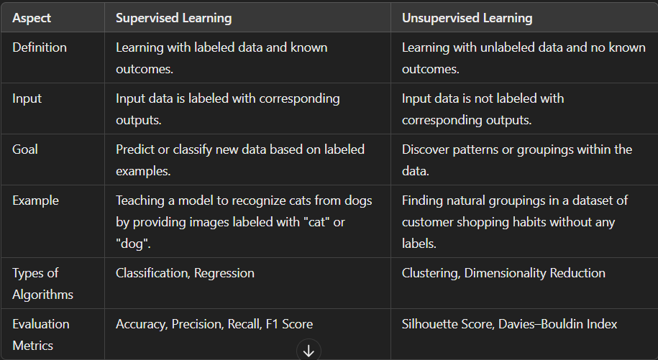

**9.Different types of learning in ML?**

**Supervised Learning:**

**Definition**: Supervised learning is like having a teacher guiding you through a lesson. You're given examples with labels (the correct answers), and your job is to learn from those examples to predict or classify new data.

**Example**: Imagine you're learning to identify different types of fruit. Your teacher shows you various fruits like apples, oranges, and bananas, and tells you what each one is. You study these examples, noting their colors, shapes, and other features. Then, your teacher shows you a new fruit—a peach—and asks you to identify it. Based on what you've learned from the labeled examples, you confidently say, "That's a peach!"

**Key Points**:

* You're given labeled examples with known outcomes.
* You learn to predict or classify new data based on those examples.
* Common tasks include classification (e.g., identifying objects in images) and regression (e.g., predicting house prices).

**Unsupervised Learning:**

**Definition**: Unsupervised learning is like exploring a new place without a map or guide. You're given data without labels, and your goal is to find patterns or groupings within that data without knowing what you're looking for in advance.

**Example**: Imagine you're given a bag of various colored marbles and asked to group them. Without any labels or instructions, you start sorting the marbles based on their colors. After a while, you notice that some marbles are similar in color and size, forming natural groups. You've discovered these groupings without any prior knowledge of what the groups should be.

**Key Points**:

* You're given unlabeled data without known outcomes.
* You explore the data to find patterns, clusters, or structures.
* Common tasks include clustering (e.g., grouping customers based on their purchasing behavior) and dimensionality reduction (e.g., simplifying high-dimensional data).

**Reinforcement Learning:**

**Scenario**: Imagine you have a robot in a maze, and its task is to reach a specific destination from a starting point. The robot doesn't have a map of the maze but can explore and learn through trial and error.

**Actions**: The robot can take various actions, such as moving forward, turning left, turning right, or staying in place.

**Environment**: The maze serves as the environment, with walls, corridors, and the destination. The robot's actions affect its position within the maze.

**Rewards**: The robot receives rewards or penalties based on its actions:

* If the robot moves closer to the destination without hitting obstacles, it receives a positive reward.
* If the robot hits a wall or moves away from the destination, it receives a negative reward.

**Learning Process**:

1. **Exploration**: Initially, the robot explores the maze randomly, trying different actions and observing the outcomes.
2. **Learning**: Based on the rewards received, the robot learns which actions are more likely to lead it closer to the destination.
3. **Optimization**: Over time, the robot adjusts its actions to maximize the cumulative rewards, gradually improving its navigation skills.

**10.what is Machine learning?**

Machine learning is a subset of artificial intelligence that enables computers to learn from data without being explicitly programmed. It involves algorithms that improve their performance over time as they are exposed to more data, allowing them to make predictions or decisions without human intervention.

**11.difference between AI and ML?**

|  |  |
| --- | --- |
| **AI** | **ML** |
| 1.AI stands for Artificial Intelligence. It is capable of acquiring and applying the knowledge or skill. | 1.ML stands for machine learning. It is the ability of the machine to learn from data and make predictions or decisions. |
| 2.The main aim of AI is to improve the success of the application. | 2.The main aim of ML is to improve the accuracy of the model. |
| 3.AI is a broader concept which has sub components like ML and DL. | 3.ML is a sub component of AI. |
| 4.AI can work with structured, semi structured and unstructured data. | 4.ML can work with only structured or semi structured data. |
| 5.Example :  Apple Siri  Google Okgoogle | 5.Examples :  Movie recommendation System  Online product recommending. |

**Difference between CS and DS**

|  |  |
| --- | --- |
| **Computer Science** | **Data Science** |
| 1. **Computer Science**can be referred to as the study of computers as well as computing concepts. It deals with both hardware and software related components and how they work. | 1. **Data Science**is basically a field in which information and knowledge are extracted from the data by using various scientific methods, algorithms, and processes |
| 2.CS is the superset of datascience. | 2.DS is subset of CS. |
| 3.Provides the foundational knowledge and skills necessary to develop software and computational systems. | 3.Focuses on the analysis and interpretation of data to extract meaningful insights. |
| 4.It is applied to nearly all the technical industries and companies. | 4. It is basically applied to the industries and companies where data is of quite a lot importance. |
|  |  |

**12.what is a neural network?**

A neural network is a computational model inspired by the structure and function of the human brain. It consists of interconnected nodes organized into layers, where each node processes information and passes it to the next layer. Through a process called training, neural networks learn to recognize patterns and make predictions from data.

**13.How does a neural networks work explain?**

• **Input Layer**: The neural network starts with an input layer, where data is fed into the network. Each input corresponds to a feature or attribute of the data being processed.

• **Hidden Layers**: Between the input and output layers, there are one or more hidden layers. Each layer consists of nodes (also called neurons) connected to the nodes in the previous layer. These connections have associated weights that determine the strength of the connection.

• **Activation Function**: Each node in the hidden layers applies an activation function to the weighted sum of its inputs. This activation function introduces non-linearity into the network, allowing it to learn complex patterns in the data.

• **Output Layer**: The final layer, known as the output layer, produces the network's prediction or output based on the activations of the nodes in the hidden layers. The number of nodes in the output layer depends on the type of problem the neural network is solving (e.g., regression, classification).

• **Training**: During training, the neural network adjusts the weights of its connections based on the difference between its predictions and the actual outputs (known as the loss). This process, known as backpropagation, uses optimization algorithms like gradient descent to minimize the loss and improve the network's performance.

• **Prediction**: Once trained, the neural network can make predictions on new, unseen data by passing it through the network and generating an output based on the learned patterns in the training data.

**14.explain how back propogation works in neural networks?**

• **Forward Pass**:

* During the forward pass, input data is fed into the neural network, and its predictions are calculated layer by layer until the output is obtained.
* Each neuron in the network computes a weighted sum of its inputs and applies an activation function to produce an output (activation).

• **Calculate Loss**:

* Once the output is obtained, the network's prediction is compared to the actual target output, resulting in an error or loss value.
* The loss function measures the discrepancy between the predicted output and the actual target output.

• **Backward Pass (Backpropagation)**:

* In the backward pass, the error is propagated backward through the network, layer by layer, to update the weights of connections between neurons.
* Starting from the output layer and moving backward through the network, the algorithm calculates the gradient of the loss function with respect to each weight.

• **Gradient Descent**:

* Once the gradients of the loss function with respect to the weights are calculated, the network updates the weights using an optimization algorithm such as gradient descent.
* Gradient descent adjusts the weights in the direction that minimizes the loss, effectively reducing the error in the network's predictions.

• **Iterative Process**:

* The process of forward pass, loss calculation, backward pass, and weight updates is repeated iteratively for multiple epochs or until the network's performance converges to a satisfactory level.
* Each iteration of this process helps the network learn and improve its ability to make accurate predictions on new data.

**15.what are activation functions and what is their role in neural networks?**

Activation functions are mathematical functions applied to the output of each neuron in a neural network's hidden layers. They introduce non-linearity into the network, enabling it to learn and model complex relationships in the data. Here's their role explained:

**Role of Activation Functions:**

1. **Introduce Non-linearity**:
   * Activation functions introduce non-linearity into the network, allowing it to learn complex patterns and relationships in the data that may be non-linear.
   * Without activation functions, the entire neural network would collapse into a single linear function, limiting its ability to model complex data.
2. **Enable Learning of Complex Patterns**:
   * By applying non-linear transformations to the weighted sum of inputs, activation functions enable neural networks to learn and represent complex patterns and features in the data.
   * This flexibility allows neural networks to capture intricate relationships and dependencies between input features, leading to more accurate predictions.
3. **Ensure Gradient Flow**:
   * Activation functions play a crucial role in ensuring the efficient flow of gradients during backpropagation, the process by which neural networks are trained.
   * They help prevent the vanishing gradient problem, where gradients become extremely small during backpropagation, hindering learning in deep neural networks.

**Python Pandas Module**

The Python pandas module is a powerful tool for data manipulation and analysis. Here's how it can be useful for data analytics:

1. **Data Structures**:
   * pandas provides two primary data structures: Series and DataFrame.
   * Series is a one-dimensional labeled array capable of holding any data type (e.g., integers, strings, floats).
   * DataFrame is a two-dimensional labeled data structure resembling a table or spreadsheet, consisting of rows and columns.
2. **Data Manipulation**:
   * pandas offers a wide range of functions and methods for data manipulation, including filtering, selecting, sorting, grouping, and aggregating data.
   * It allows you to perform operations on entire columns or rows of data, such as arithmetic operations, string manipulations, and missing data handling.
3. **Data Cleaning**:
   * pandas provides tools for cleaning and preprocessing data, such as handling missing or duplicate values, converting data types, and removing outliers.
   * It allows you to apply custom functions to transform or clean data efficiently.
4. **Data Exploration**:
   * pandas enables you to explore and understand your data through descriptive statistics, visualization, and exploratory data analysis (EDA).
   * It offers functions for generating summary statistics, histograms, box plots, scatter plots, and more, helping you identify patterns, trends, and relationships in your data.

**Difference between loc() and iloc()**

loc and iloc are both pandas DataFrame methods used for accessing data, but they have different purposes and syntax:

1. **loc**:
   * loc is primarily label-based indexing. It is used to access rows and columns in a DataFrame using their labels (index and column names).
   * Syntax: df.loc[row_label, column_label]
   * Example: df.loc[3, 'Name'] would return the value in the 'Name' column of the row with index label 3.
2. **iloc**:
   * iloc is primarily integer-based indexing. It is used to access rows and columns in a DataFrame using integer indices (position-based indexing).
   * Syntax: df.iloc[row_index, column_index]
   * Example: df.iloc[2, 1] would return the value in the second column of the third row (both indices are zero-based).

**Some useful in built functions of pandas**

1. Head()
2. Tail()
3. Describe()
4. Info()
5. Read_csv()
6. Dropna()
7. Series()
8. DataFrame()
9. Fillna()
10. Mean()
11. Median()
12. Mode()
13. Index
14. Drop_duplicates()

**What are regular expressions in java?**

Regular expressions (regex) in Java are a powerful tool used for pattern matching and manipulation of text. They provide a way to search, match, and manipulate strings based on specific patterns. Java provides the java.util.regex package for working with regular expressions.

**Common Regex Constructs**

* **Character Classes**:
  + . : Any character (except newline)
  + \d : A digit
  + \D : A non-digit
  + \w : A word character (alphanumeric plus "_")
  + \W : A non-word character
  + \s : A whitespace character
  + \S : A non-whitespace character
  + [abc] : Any of a, b, or c
  + [^abc] : Not a, b, or c
  + [a-z] : A character from a to z
* **Quantifiers**:
  + * : Zero or more
  + + : One or more
  + ? : Zero or one
  + {n} : Exactly n
  + {n,} : n or more
  + {n,m} : Between n and m

**What is Big data? Explain its 5 v’s?**

Big data refers to larger amounts of data which gets generated exponentially with respect to time. This big data cannot be processed or analyzed using the traditional data processing techniques. They are characterized by their size, complexity and at the speed the data is generated.

**The 5 V's of Big Data**

The five V's of big data are Volume, Velocity, Variety, Veracity, and Value. These characteristics help to define and understand the nature and challenges of big data.

1. **Volume**
   * **Definition**: The amount of data being generated and collected.
   * **Explanation**: Big data typically involves massive volumes of data. This data comes from various sources like social media, sensors, transaction records, and more. The volume can be in terabytes, petabytes, or even exabytes.
   * **Example**: Social media platforms generate vast amounts of data every second from user interactions, posts, likes, shares, and comments.
2. **Velocity**
   * **Definition**: The speed at which data is generated, collected, and processed.
   * **Explanation**: Big data is not only about the size but also about the fast pace at which new data is created and needs to be processed. This often requires real-time or near-real-time data processing capabilities.
   * **Example**: Financial markets require rapid processing of stock price data to make timely trading decisions.
3. **Variety**
   * **Definition**: The different types and sources of data.
   * **Explanation**: Big data comes in various formats, including structured data (like databases), semi-structured data (like XML, JSON), and unstructured data (like text, images, videos). This variety makes data processing and analysis more complex.
   * **Example**: Analyzing customer feedback may involve processing text from emails, images from social media, and voice recordings from customer service calls.
4. **Veracity**
   * **Definition**: The quality and accuracy of the data.
   * **Explanation**: Not all data is clean or accurate. Veracity refers to the trustworthiness and reliability of the data. Inaccurate or incomplete data can lead to misleading insights, so ensuring data quality is crucial.
   * **Example**: Data from social media can be noisy and may contain false information, which requires cleaning and validation before analysis.
5. **Value**
   * **Definition**: The useful insights and benefits that can be derived from the data.
   * **Explanation**: Ultimately, the goal of big data is to extract valuable insights that can inform decision-making and drive business value. This involves using data analytics, machine learning, and other tools to uncover patterns and trends.
   * **Example**: Retail companies can analyze big data to understand customer preferences and behaviors, leading to more effective marketing strategies and personalized customer experiences.

**Where do you think big data can be useful? Tell me the applications with proper example?**

Big data can be useful across a wide range of industries and applications. Here are some key areas where big data is making a significant impact, along with specific examples:

**1. Healthcare**

* **Application**: Predictive Analytics for Patient Care
* **Example**: Hospitals and healthcare providers use big data analytics to predict patient readmissions. By analyzing patient records, treatment histories, and demographic data, predictive models can identify patients at high risk of readmission, allowing for proactive interventions to improve care and reduce costs.

**2. Finance**

* **Application**: Fraud Detection and Prevention
* **Example**: Banks and financial institutions use big data to monitor transactions in real-time and identify suspicious activities that could indicate fraud. Machine learning algorithms analyze transaction patterns and flag anomalies, enabling quick responses to prevent fraudulent transactions.

**3. Retail**

* **Application**: Personalized Marketing and Customer Experience
* **Example**: E-commerce platforms like Amazon use big data to analyze customer behavior, purchase history, and browsing patterns. This data is used to recommend products, personalize shopping experiences, and optimize pricing strategies, leading to increased sales and customer satisfaction.

**4. Manufacturing**

* **Application**: Predictive Maintenance
* **Example**: Manufacturing companies use big data from sensors embedded in machinery to predict equipment failures before they occur. By analyzing data on machine performance, temperature, and vibration, companies can schedule maintenance activities at optimal times, reducing downtime and maintenance costs.

**Explain about Hadoop and its components?**

Hadoop is an open-source framework that allows for the distributed processing of large data sets across clusters of computers using simple programming models.

It is designed to handle big data and is based on the MapReduce programming model, which allows for the parallel processing of large datasets.

* HDFS (Hadoop Distributed File System): This is the storage component of Hadoop, which allows for the storage of large amounts of data across multiple machines. It is designed to work with commodity hardware, which makes it cost-effective.
* YARN (Yet Another Resource Negotiator): This is the resource management component of Hadoop, which manages the allocation of resources (such as CPU and memory) for processing the data stored in HDFS.
* Hadoop also includes several additional modules that provide additional functionality, such as Hive (a SQL-like query language), Pig (a high-level platform for creating MapReduce programs), and HBase (a non-relational, distributed database).
* Hadoop is commonly used in big data scenarios such as data warehousing, business intelligence, and machine learning. It’s also used for data processing, data analysis, and data mining. It enables the distributed processing of large data sets across clusters of computers using a simple programming model.

**Advantages of Hadoop**

* Ability to store a large amount of data.
* High flexibility.
* High computational power.
* Tasks are independent.

**Disadvantages of Hadoop**

* Not very effective for small data.
* Hard cluster management.
* Has stability issues.
* Security concerns.
* Expensive to setup

**What is map reduce programming? Explain?**

MapReduce is a programming model and processing technique for handling and generating large data sets with a parallel, distributed algorithm on a cluster (many computers working together). The idea is to split a large task into smaller tasks, process them in parallel, and then combine the results.

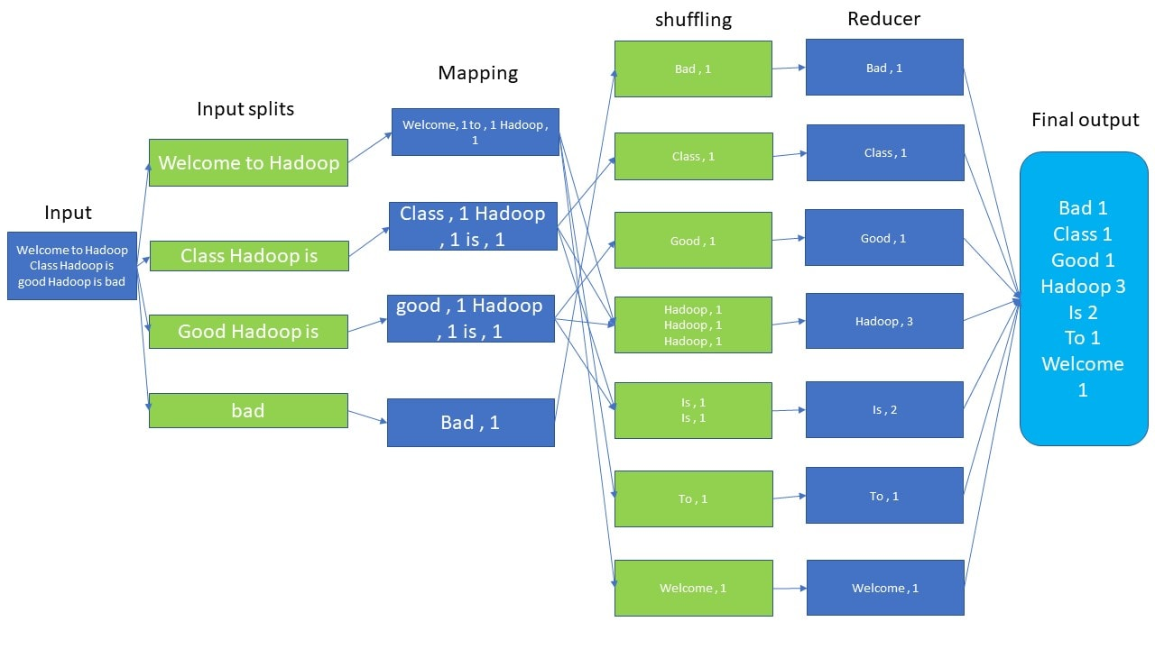

The MapReduce model consists of two main phases: **Map** and **Reduce**. Here's how each phase works:

1. **Map Phase**
   * **Input:** A large data set.
   * **Process:** The Map function takes each piece of data and processes it independently. It transforms the input data into a set of intermediate key-value pairs.
   * **Output:** Intermediate key-value pairs.

**Example:** Imagine you have a huge list of words, and you want to count how many times each word appears.

* + **Input:** "apple", "banana", "apple", "cherry", "banana", "apple".
  + **Map Function:** It processes each word and emits key-value pairs like ("apple", 1), ("banana", 1), etc.
  + **Output:** [("apple", 1), ("banana", 1), ("apple", 1), ("cherry", 1), ("banana", 1), ("apple", 1)].

1. **Shuffle and Sort Phase**
   * **Process:** After the Map phase, the system groups all the values by their key. This means all the values associated with the same key are collected together.
   * **Output:** A list of keys with their associated values.

**Example:** From the Map output, group by key.

* + **Input:** [("apple", 1), ("banana", 1), ("apple", 1), ("cherry", 1), ("banana", 1), ("apple", 1)].
  + **Grouped Output:** [("apple", [1, 1, 1]), ("banana", [1, 1]), ("cherry", [1])].

1. **Reduce Phase**
   * **Input:** The grouped intermediate key-value pairs from the Shuffle and Sort phase.
   * **Process:** The Reduce function processes each group of key-value pairs and combines them to form a smaller set of output values.
   * **Output:** The final result of the computation.

**Example:** Sum the values for each key.

* + **Input:** [("apple", [1, 1, 1]), ("banana", [1, 1]), ("cherry", [1])].
  + **Reduce Function:** It sums the values for each key, resulting in key-value pairs like ("apple", 3), ("banana", 2), ("cherry", 1).
  + **Output:** [("apple", 3), ("banana", 2), ("cherry", 1)].

**HDFS Server Roles**

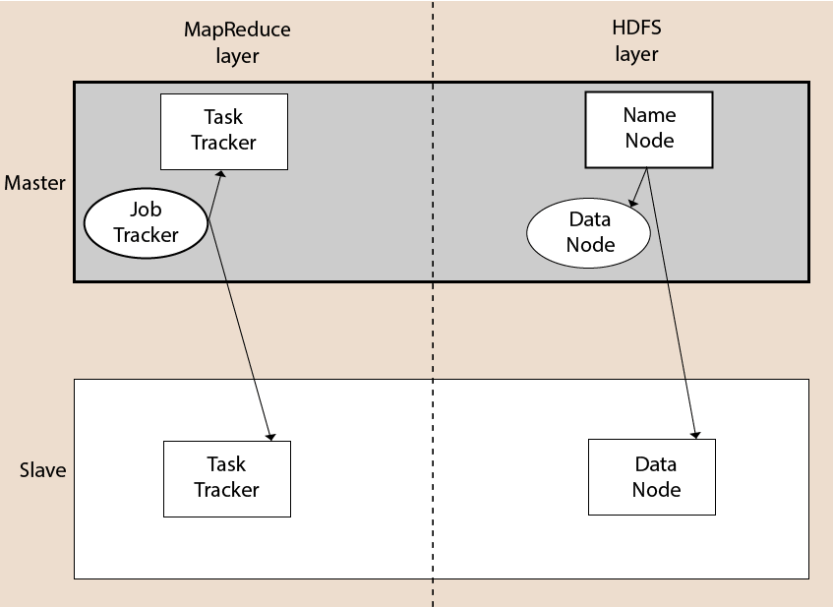

**1. NameNode**

* **Role:** The boss of the file storage system.
* **Responsibilities:** It keeps track of where all your files are stored within the cluster. Imagine a library where the librarian (NameNode) knows exactly which book (data) is on which shelf (DataNode). The NameNode doesn’t hold the books themselves but keeps the index of where each book is located.

**2. DataNode**

* **Role:** The worker bees of the file storage system.
* **Responsibilities:** They actually store the pieces of your files. If your data is a big book, it’s split into chapters, and each DataNode holds a few chapters. They report back to the NameNode with the status of the storage and respond to read and write requests from clients.

**3. JobTracker**

* **Role:** The manager of task assignments.
* **Responsibilities:** When you want to process data, the JobTracker decides how to divide the job into smaller tasks and assigns these tasks to different TaskTrackers (workers). Think of it as a manager in a factory who assigns tasks to different workers to complete a big project.

**4. TaskTracker**

* **Role:** The worker that executes tasks.
* **Responsibilities:** They receive tasks from the JobTracker and execute them on the data stored in the DataNodes. After completing the task, they report the status back to the JobTracker. If a TaskTracker fails, the JobTracker reassigns the task to another TaskTracker.

**Internal working of Hadoop**

**Analogy**

Imagine you have a large book that you want to store in a library:

* **Splitting the Book:** You divide the book into chapters (blocks).
* **Storing Chapters:** You place different chapters on different shelves (DataNodes).
* **Multiple Copies:** To ensure the book is not lost, you make several copies of each chapter and place them on different shelves.
* **Library Catalog:** The librarian (NameNode) keeps a catalog of where each chapter is stored.
* **Reading the Book:** When you want to read the book, you ask the librarian where each chapter is, and then you go directly to the shelves to get the chapters.

**Cloud Computing**

Cloud computing refers to the delivery of computing services—such as servers, storage, databases, networking, software, and more—over the internet ("the cloud"). Instead of owning and maintaining physical hardware and infrastructure, users can access these services on-demand from cloud providers. Cloud computing offers several types of services, often categorized into three main models:

**Why cloud computing?**

Generally, when an IT company is formed the company makes sure that it maintains a server room. Mostly the server room consists of the database servers, routers ,modems, mail servers and QPS(Query per second),high net speed and at last the maintenance engineers.

All this requires a lot of money to setup. To avoid all these we can use cloud computing services.

**Types of Cloud Computing Services**

1. **Infrastructure as a Service (IaaS)**
   * **Explanation**: IaaS provides virtualized computing resources over the internet. It allows users to rent virtual machines, storage, and networking infrastructure on a pay-as-you-go basis.
   * **Easy Example**: Imagine renting a fully equipped virtual office space. You get access to desks, computers, internet connections, and other essentials, but you don't own or maintain any of it—you simply pay for what you use.
2. **Platform as a Service (PaaS)**
   * **Explanation**: PaaS provides a platform allowing customers to develop, run, and manage applications without the complexity of building and maintaining the underlying infrastructure. It typically includes development tools, database management systems, and middleware.
   * **Easy Example**: Think of a fully furnished kitchen in a restaurant where you can cook your meals without worrying about purchasing or maintaining the equipment (ovens, stoves, utensils). You focus on cooking (developing applications), while the platform (kitchen) provides all necessary tools and resources.
3. **Software as a Service (SaaS)**
   * **Explanation**: SaaS delivers software applications over the internet on a subscription basis. Users access these applications via a web browser without needing to install or manage any software locally.
   * **Easy Example**: Using a streaming service like Netflix. You don't own the movies or the servers streaming them—you simply pay for the service and access the content anytime, anywhere.

**Key Benefits of Cloud Computing**

* **Scalability**: Easily scale resources up or down based on demand.
* **Cost Efficiency**: Pay only for what you use, with no upfront investment in hardware.
* **Accessibility**: Access data and applications from anywhere with an internet connection.
* **Reliability**: Cloud providers often offer robust infrastructure with high availability and redundancy.
* **Flexibility**: Choose from various service models and deployment options based on your needs.

**1. Public Cloud**

* **Explanation**: In a public cloud model, cloud services are provided over the internet by third-party providers. These services are shared among multiple organizations, making it a cost-effective option for many users. Users pay for the resources they consume on a pay-as-you-go basis.
* **Example**: Imagine you need storage space for your personal files. Instead of buying an external hard drive or setting up your own server, you subscribe to a cloud storage service like Google Drive or Dropbox. You upload your files to their servers, and you can access them from any device with an internet connection. The service provider manages the infrastructure, security, and maintenance of the storage servers.

**2. Private Cloud**

* **Explanation**: A private cloud is dedicated to a single organization and is either managed internally or by a third-party provider. It offers more control, customization, and security compared to a public cloud. It can be hosted on-premises or in a data center.
* **Example**: Consider a large corporation that handles sensitive customer data, such as a bank. They may opt to set up a private cloud infrastructure to store and manage their data and applications. This private cloud allows them to have strict control over security measures and compliance requirements. The company's IT department manages and maintains the infrastructure, ensuring it meets the organization's specific needs and standards.

**3. Hybrid Cloud**

* **Explanation**: A hybrid cloud combines elements of both public and private clouds. It allows data and applications to be shared between them, providing greater flexibility and optimization of resources. Organizations can use a hybrid approach to leverage the benefits of both cloud models.
* **Example**: Imagine a retail company that uses a private cloud for sensitive customer data and a public cloud for their e-commerce website. The private cloud stores customer information securely, while the public cloud hosts the website, handling variable traffic loads during sales events. The hybrid cloud setup allows the company to scale resources dynamically, ensuring both security and performance based on specific business needs.

**Characteristics of Cloud computing**

* The chance of server failure is minimum.
* It offers various resources on demand to the users without having engineers at peak load.
* Multiple users and applications can work efficiently without any issue.
* Cloud computing enables users to access the resources from anywhere through out the world via internet.

**Advantages of Cloud computing**

* Once the data is stored in the cloud, it can be accessed easily from anywhere through out the world.
* Cloud applications provide collaborations of users where multiple users can share and retrieve the same data very easily.
* It reduces the software and hardware maintenance cost for the companies.
* Offers huge amount of storage capacity to the users to store all types of data.
* Cloud ensures that the data is stored with high security.

**Disadvantages of Cloud computing**

* Whenever we want to access the data in the cloud we definitely require a smooth internet connectivity. Otherwise it becomes difficult to upload or download the data.
* cloud infrastructure is completely owned, managed, and monitored by the service provider, so the cloud users have less control over the function and execution of services within a cloud infrastructure.
* Although cloud service providers implement the best security standards to store important information. But, before adopting cloud technology, you should be aware that you will be sending all your organization's sensitive information to a third party, i.e., a cloud computing service provider. While sending the data on the cloud, there may be a chance that your organization's information is hacked by Hackers.

**Security risks of cloud computing**

Think of cloud computing like storing your important stuff in a shared storage room. While it's convenient, there are some security risks to consider:

1. **Data Breaches:** Just like someone could break into the storage room, hackers might try to access your cloud data without permission.
2. **Loss of Control:** Since your stuff is in someone else's storage room (cloud server), you have less control over its security measures.
3. **Data Loss:** If the storage room (cloud server) has a problem, like a fire or a crash, your stuff could get damaged or lost.
4. **Privacy Concerns:** If the storage room is managed by others, they might be able to see or use your stuff, even if it's unintentional.
5. **Account Hijacking:** If someone gets access to your "key" (account credentials), they could get into your storage room (cloud account) and mess with your stuff.

**Machine learning types :**

**Simple Linear Regression :** Linear regression is a statistical method used to model the relationship between a dependent variable (also called the response or target variable) and one or more independent variables (also called predictors or features). The goal is to find a linear equation that best predicts the dependent variable based on the values of the independent variables.

**Key Concepts**

1. **Dependent and Independent Variables:**
   * **Dependent Variable (Y):** The variable that we are trying to predict or explain.
   * **Independent Variables (X):** The variables that are used to predict the dependent variable.
2. **Linear Relationship:**
   * Linear regression assumes that the relationship between the dependent and independent variables can be described with a straight line (in the case of one independent variable) or a hyperplane (in the case of multiple independent variables).
3. **Equation of the Line:**
   * In simple linear regression (one independent variable), the relationship is modeled by the equation:

Y=β0+β1X+ϵY = \beta_0 + \beta_1X + \epsilonY=β0​+β1​X+ϵ where β0\beta_0β0​ is the intercept, β1\beta_1β1​ is the slope, and ϵ\epsilonϵ is the error term.

* + In multiple linear regression (multiple independent variables), the equation extends to: Y=β0+β1X1+β2X2+⋯+βnXn+ϵY = \beta_0 + \beta_1X_1 + \beta_2X_2 + \cdots + \beta_nX_n + \epsilonY=β0​+β1​X1​+β2​X2​+⋯+βn​Xn​+ϵ where βi\beta_iβi​ (for i=0,1,2,...,ni = 0, 1, 2, ..., ni=0,1,2,...,n) are the coefficients.

**Multiple Linear Regression**

Multiple linear regression is an extension of simple linear regression that models the relationship between a dependent variable and two or more independent variables. This method is used when you want to understand how multiple factors (independent variables) collectively impact a single outcome (dependent variable).

**Key Concepts**

1. **Dependent and Independent Variables:**
   * **Dependent Variable (Y):** The outcome or the variable that you want to predict or explain.
   * **Independent Variables (X1, X2, ..., Xn):** The predictors or factors that are used to predict the dependent variable.
2. **Linear Relationship:**
   * Multiple linear regression assumes that the relationship between the dependent variable and each independent variable is linear. The combined effect of the independent variables on the dependent variable is modeled by a linear equation.
3. **Equation of the Model:**
   * The relationship in multiple linear regression is modeled by the equation: Y=β0+β1X1+β2X2+⋯+βnXn+ϵY = \beta_0 + \beta_1X_1 + \beta_2X_2 + \cdots + \beta_nX_n + \epsilonY=β0​+β1​X1​+β2​X2​+⋯+βn​Xn​+ϵ where:
     + YYY is the dependent variable.
     + X1,X2,...,XnX_1, X_2, ..., X_nX1​,X2​,...,Xn​ are the independent variables.
     + β0\beta_0β0​ is the intercept (the expected value of YYY when all XXX variables are 0).
     + β1,β2,...,βn\beta_1, \beta_2, ..., \beta_nβ1​,β2​,...,βn​ are the coefficients (representing the change in YYY for a one-unit change in the respective XXX variable).
     + ϵ\epsilonϵ is the error term (the difference between the observed and predicted values of YYY).

**Logistic Regression**

Logistic regression is a statistical method used for modeling the relationship between a dependent variable and one or more independent variables, where the dependent variable is categorical. It is most commonly used when the dependent variable is binary (i.e., it has two possible outcomes such as "yes" or "no", "success" or "failure", "1" or "0").

**Key Concepts**

1. **Dependent and Independent Variables:**
   * **Dependent Variable (Y):** The outcome or target variable, which is categorical. In binary logistic regression, it typically takes values 0 or 1.
   * **Independent Variables (X1, X2, ..., Xn):** The predictors or explanatory variables, which can be continuous, categorical, or a mix of both.
2. **Logistic Function (Sigmoid Function):**
   * The core of logistic regression is the logistic function, which maps any real-valued number into the (0, 1) interval, making it suitable for modeling probabilities.
   * The logistic function is given by: logit(p)=ln⁡(p1−p)=β0+β1X1+β2X2+⋯+βnXn\text{logit}(p) = \ln \left( \frac{p}{1-p} \right) = \beta_0 + \beta_1X_1 + \beta_2X_2 + \cdots + \beta_nX_nlogit(p)=ln(1−pp​)=β0​+β1​X1​+β2​X2​+⋯+βn​Xn​ where ppp is the probability that the dependent variable YYY equals 1 (i.e., the event occurs).

**Classification in Machine learning**

Classification is a type of supervised machine learning technique used to predict the category or class of a given data point based on its features. The goal of classification is to assign labels to new observations based on the patterns learned from a labeled dataset during training. Classification problems can have binary outcomes (two classes) or multiple outcomes (more than two classes).

**Binary Classification:**

* In binary classification, the target variable has only two possible classes. Examples include:
  + Spam detection: Classifying emails as "spam" or "not spam."
  + Disease prediction: Predicting whether a patient has a disease ("positive") or not ("negative").
* Common algorithms: Logistic Regression, Support Vector Machines (SVM), Decision Trees, Random Forests, and Naive Bayes.

**Multiclass Classification:**

* In multiclass classification, the target variable has more than two classes. Examples include:
  + Handwritten digit recognition: Classifying images of handwritten digits into 0-9.
  + Animal classification: Classifying images of animals into categories like "cat," "dog," "horse," etc.
* Common algorithms: Multinomial Logistic Regression, Decision Trees, Random Forests, k-Nearest Neighbors (k-NN), and Neural Networks.

**What is Random Forest?**

Ensemble learning combines multiple models to improve the overall performance compared to individual models. Random Forest is an example of a bagging (Bootstrap Aggregating) ensemble technique.

Random Forest is an ensemble learning method used for classification, regression, and other tasks that operates by constructing a multitude of decision trees during training and outputting the class (classification) or mean prediction (regression) of the individual trees. It is a versatile and powerful machine learning algorithm known for its robustness and ability to handle large datasets with higher dimensionality.

**Boosting and Bagging**

**Bagging (Bootstrap Aggregating)**

Bagging is a technique in which multiple models are trained independently on different random subsets of the training data. These subsets are created by randomly sampling with replacement, meaning some data points may be repeated while others may be left out. Each model then makes predictions, and the final prediction is obtained by averaging (for regression) or taking a majority vote (for classification) of all the individual models' predictions. This approach helps to reduce the model's variance and improves its stability and accuracy by combining the strengths of multiple models, making it less likely to overfit the data.

**Boosting**

Boosting, on the other hand, is a technique where models are trained sequentially, with each new model trying to correct the errors made by the previous ones. Initially, all data points are given equal weight, but as the process continues, the weights of misclassified points are increased so that subsequent models focus more on these difficult cases. The final prediction is a weighted combination of all the models' predictions, with more accurate models having higher weights. This method reduces both bias and variance, often leading to highly accurate models, but it can be more prone to overfitting and is computationally intensive due to its iterative nature.

**Variance and Standard Deviation**

Variance is a statistical measure that represents the dispersion or spread of a set of data points around their mean (average) value. It quantifies how much the data points differ from the mean, providing insight into the data's variability. The formula for variance is different for a sample and a population.

Standard deviation is a measure of the amount of variation or dispersion in a set of data points. It is the square root of the variance and provides a measure of the average distance of the data points from the mean. Standard deviation is expressed in the same units as the data, making it more interpretable than variance.

**Use of these:**

Features with low variance are often less informative and might be considered for removal, as they do not help in distinguishing between different classes. Conversely, features with higher variance might carry more useful information for the model.

High variance in a feature can sometimes indicate the presence of outliers. By understanding the standard deviation, you can identify data points that are far from the mean, which could be potential outliers or anomalies.